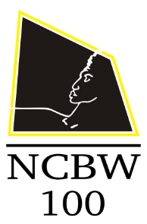
National Coalition of 100 Black Women, Inc.
Prince William County Chapter, Inc.

2019 Chapter Member Recognition Form

2019 Recognition Focus – Health Advocacy

The program will recognize the accomplishments and work of African American women across generations who are working toward improving women’s physical and mental health.

In addition, NCBW-PWCC members who are engaged in health advocacy will be recognized.

If you are engaged in health advocacy as a profession, please submit this brief form via email to:

Member Name:

Organization/Company/Practice:

Position:

Advocacy:

Submit to
NCBWAwards2019@gmail.com

