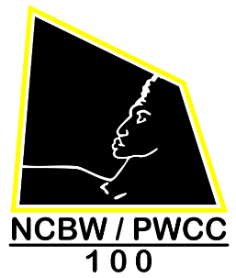
April 11, 2020

Dear Mental Health & Wellness Expo Participants,

This email is to inform you, that the National Coalition of 100 Black Women; Prince William County Chapter, Inc. Mental Health & Wellness Expo, which is scheduled on May 16, 2020, has been postponed due to the Coronavirus Pandemic. The health and safety of our community is extremely important to us therefore; on a monthly basis, we will be informing you about any
Mental Health & Wellness Expo Program changes.

We ask that you continue to be vigilant in taking the necessary precautions in response to the increasing coronavirus pandemic and pray for people around the world.
Carolyn, Sylvia & I sincerely thank everyone for all their support.

Regards,
Carolyn Custard, Chairperson
Roxie B. Curtis, Co-chairperson
Sylvia Beach, Chairperson of Resources

cc: Ms. Shelia D. Coleman, President
Dr. Alice Howard, Immediate Past President, Organizer & Director of Grants
NCBW PWCC Chapter Members

