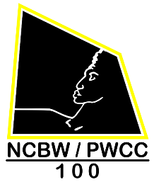
NCBW PWCC 2018 Gala Fundraiser Summary
“Harlem Nights…Celebrating Black Excellence"
2nd VP Report
Executive Board Meeting Report
Tuesday, September 11, 2018

- Location: Hyatt Regency Hotel, 2799 Jefferson Davis Highway, Arlington, VA
- We have 75 blocked/reserved rooms at the hotel
- Friday, November 9, 2018 and Saturday, November 10, 2018
- Room rate per night is $95.00 plus taxes the cost is $107.59
- When making reservations, please mention Group Name - National Coalition of 100
- Also, mention Group Code – G-100L
- Reservation Telephone Number: 1-800-323-7249
- Hotel Direct Number: 703-418-1234
- For Online Reservation Code:
https://book.passkey.com/go/NationalCoalition100BlackWomen
- Last date to register is Wednesday, November 7, 2018
- Parking Fee: $13.00
- Photo cost: $20.00
- Gala tickets are: $95.00
- Ticket sales started: Wednesday, August 29, 2018
- Journal Ads Deadline: Monday October 1, 2018
- FINAL, FINAL cut-off date to purchase tickets: Friday, November 2nd @ 12pm
- Please email your submission Ad, camera ready, landscape to Mrs. Mary Lively
at mrlively @comcast.net; Mrs. Cynthia R. Brown @ cbrown0113@aol.com
- Black Tie Affair: {ladies} long evening dresses or cocktail dresses
- Chapter Sponsorship Competition Drive – Dr. Marvette Thomas

